#sinfo

scontrol update node=node1 state=down reason=maintenance

sinfo –R

scontrol update node=node1 state=resume

sinfo

To down the state of node1 and check as sinfo –R as it was unhealthy. And again resume the state.

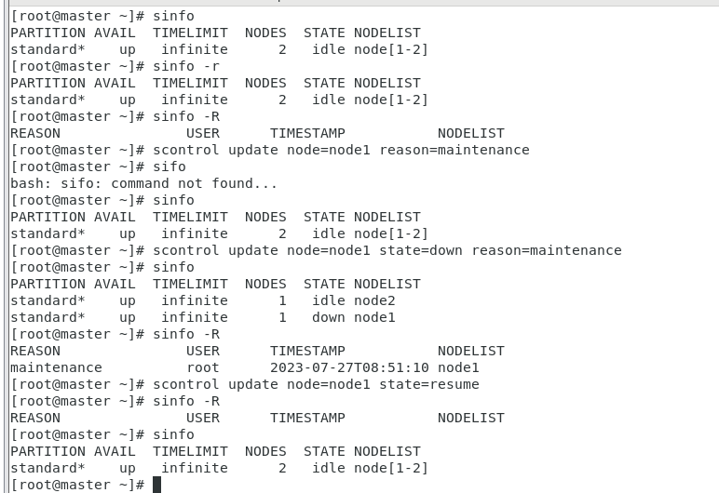

To Run the job interactively using hostname

srun -w node1 --pty /bin/bash

To Run the job interactively without knowing hostname

srun -N1 --pty /bin/bash

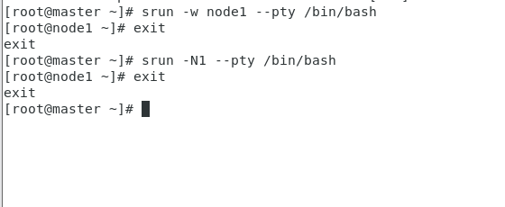

To run Job using sbatch script

Vi script.sh

#!/bin/bash

#SBATCH --partition=standard # Partition name

#SBATCH --nodes=1 # number of nodes

#SBATCH --job-name=serial_job_test # Job name

#SBATCH --cpus-per-task=1 # number of cpus per task

#SBATCH --ntasks=1 # Run on a single CPU

#SBATCH --mem=1gb # Job memory request

#SBATCH --time=00:05:00 # Time limit hrs:min:sec

#SBATCH --output=serial_test_%j.log # Standard output and error log

#SBATCH --error=error-%j.out # error file

pwd; hostname; date

module load python

echo "Running plot script on a single CPU core"

python /data/training/SLURM/plot_template.py

date

sleep 300

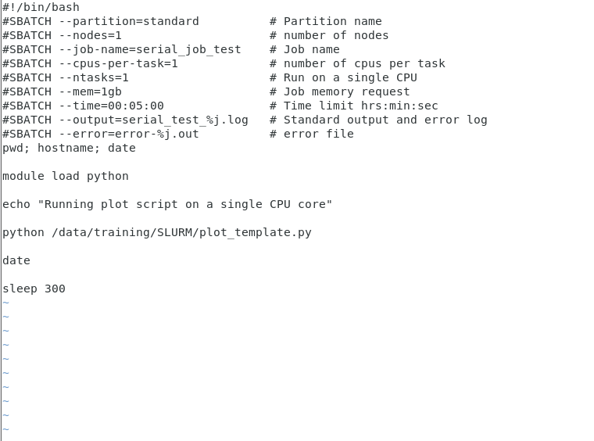

Run the script

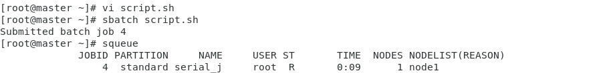

To see the job details

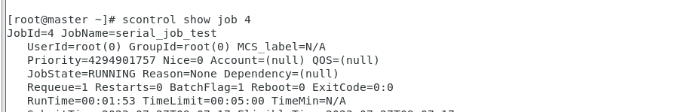

To cancel the Job

